# Multi-frame Full Matrix Capture (MFMC)

# HDF5 Structure Specification, Version 2.0.0

# Paul Wilcox (p.wilcox@bristol.ac.uk)

## Summary

The Multi-frame Full Matrix Capture (MFMC) format is a structure designed for storage of data obtained from ultrasonic array probes. It has been designed specifically for the storage of the original ultrasonic data in its raw form acquired under the paradigm of Full Matrix Capture (FMC), although the format can accommodate other acquisition modalities.

The quantum of data in the MFMC structure is a single frame of FMC data. A collection of frames where all acquisition parameters except the probe position are fixed constitutes a sequence. Typically, a sequence represents the results of a probe being scanned over a target. One MFMC structure can accommodate multiple sequences. The number of frames in any sequence is limited only by physical storage capacity and operating system constraints. Frames can be appended to sequences within an existing MFMC structure.

The underlying format is the Hierarchical Data Format (HDF5), which is structured as a hierarchy of groups containing data-fields. One or more MFMC data structures can be embedded anywhere within an HDF5 file, or a file may contain a single MFCM structure. An MFMC structure within a file is valid if the groups and data-fields in the structure conform to the MFMC specification. A valid MFMC structure can contain an unlimited number of additional groups and data-fields to provide additional functionality to satisfy the requirements of users.

## Introduction

Ultrasonic arrays containing multiple individually-addressable elements produce large quantities of data that can be used to obtain high-fidelity images of the interior of a component. Example use cases are illustrated in Fig. 1. In Fig. 1(a) a single array probe is scanned over a component and pulse-echo data from one side of the component is acquired. In Fig. 1(b), two array probes are moved, possibly independently, and through transmission data as well as pulse-echo data is acquired. The MFMC structure has been designed to allow the storage of raw array data in a general way that allows many different configurations to be accommodated.

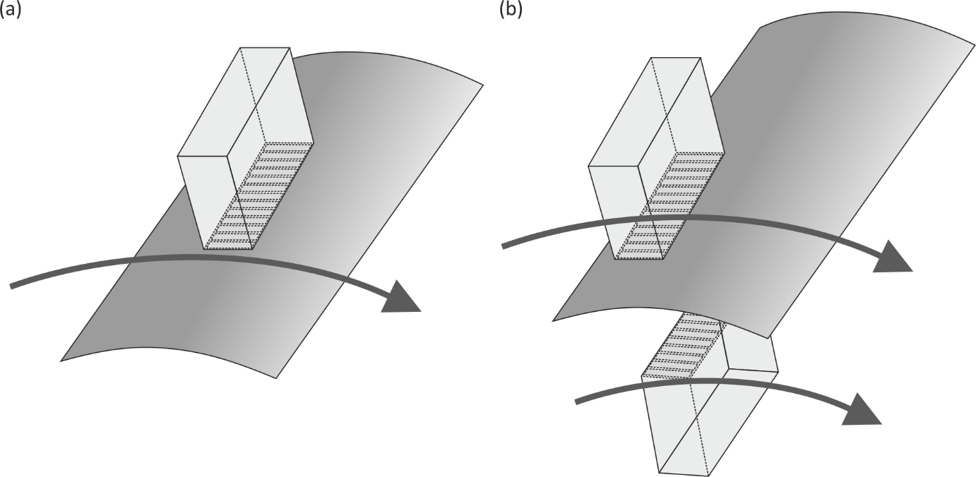

Fig. 1 Example use cases: (a) single probe scanned over component; (b) pair of probes scanned over component.

## Definitions

* Element – an individually-addressable ultrasonic transduction device;
* Placement – position and orientation of an entity (e.g. an element);
* Probe – a collection of elements with placements that are fixed relative to one another;
* Probe Element Combination (PEC) – the system used within an MFMC structure to identify a specific element in a specific probe, comprising an HDF5 reference to the probe group and the index of an element in that probe;
* Focal law – a set of instructions that specify how one or more PECs are used together;
* Transmit focal law – a focal law relating to transmission of ultrasound from one or more PECs;
* Receive focal law – a focal law relating to reception of ultrasound from one or more PECs;
* Acquisition parameters – the collection of parameters (including transmit and receive focal laws) that specify how ultrasonic data is acquired;
* A-scan – a time-domain, un-rectified ultrasonic signal (comprising amplitude measurements regularly sampled in time at a specified sampling frequency) that is recorded for a combination of transmit focal law and receive focal law;
* Frame – a collection of A-scans obtained using different transmit and receive focal laws for each A-scan;
* Sequence – a collection of frames in which all acquisition parameters except the probe position are fixed from one frame to another;
* Full Matrix Capture (FMC) – a frame of data from PECs in which the transmit and receive focal laws each specify a single PEC and A-scans from all possible combinations of transmit and receive focal laws are recorded;
* Half Matrix Capture (HMC) – a subset of FMC where acoustic reciprocity is assumed and A-scans from only the unique transmit and receive focal law combinations are recorded;
* Plane Wave Imaging (PWI) – an alternative data-acquisition modality where multiple elements are used in transmission to emit a plane wave at a specified angle;
* Probe Coordinate System (PCS) – coordinate systems (one for each probe) that describe the (fixed) relative placement of elements within a probe;
* Global Coordinate System (GCS) – the single fixed laboratory coordinate system;
* Ultrasonic time – timescale over which an individual ultrasonic A-scan is recorded, which is assumed to be instantaneous compared to timescale associated with mechanical movement of probes;

## MFMC Structure

### Overview and Naming Conventions

The overall MFMC structure within an HDF5 file is summarised in Fig. 2.

Fig. 2 Overall MFMC structure. User-specified groups and data-fields can be added as necessary at any level.

A HDF5 file contains a hierarchy of groups that contain datasets and attributes. The difference between datasets and attributes is that the latter are intended for small, fixed-size data, while the former are designed for holding multi-dimensional arrays of data. In all other respects their behaviour is the same and for brevity, the term datafield will be used to describe both unless stated.

Groups, datasets and attributes within the hierarchy are accessed via paths with the different levels in the hierarchy indicated by the / character. A valid MFMC structure can be embedded within the hierarchy of a larger HDF5 file, or it can be the only structure in a file. In the MFMC structure, paths are capitalised, e.g.

* /GROUP_LEVEL_1/…/GROUP_LEVEL_N/DATASET_NAME – dataset;
* /GROUP_LEVEL_1/…/GROUP_LEVEL_N/ATTRIBUTE_NAME – attribute.

Within the MFMC structure, each group has an associated TYPE string attribute which is either MFMC (the root group of the MFMC structure), PROBE (for a group containing details of a probe), SEQUENCE (for a group containing an MFMC sequence) or LAW (for a group containing details of a focal law). The naming of groups is at the discretion of the user; cross-references to groups are made using HDF5 reference objects.

The notation used in this document for datafield paths is as follows

* /{probe} – indicates a user-defined probe group name;
* /{sequence} – indicates a user-defined sequence group name;
* /{law} – indicates a user-defined focal law group name;
* /A_{B/C} – shorthand for specific paths /A_B and /A_C;
* /A_* – shorthand for any paths that match pattern with * as wildcard, e.g. /A_B and /A_C;
* B in /A – shorthand for path /A/B.

### Units, Character Sets, Indexing and Byte Ordering

All physical quantities should be given in SI units, the most relevant for ultrasonic array data being:

* Distances and linear dimensions in metres (m);
* Times in seconds (s);
* Frequencies in Hertz (s‑1);
* Velocities in metres per second (ms‑1).

Linear values (rather than logarithmic or decibel values) are used for describing scaling factors such as amplifier gain or Distance Amplitude Correction (DAC). Complex values are represented by their real and imaginary components (rather than amplitude and phase).

The MFMC specification does not specify the exact datatypes (e.g. number of bits, byte ordering) that are to be used but only the data class (e.g. floating point, integer). The exact datatype is recorded as part of the HDF5 format.

All strings should be ASCII-encoded.

### Dimensions, Sizes and Cross-referencing

Datafields in the MFMC structure are typically multi-dimensional arrays of numbers. The size of a datafield is given in square brackets with dimension separated by commas, e.g. [2,3]. Therefore [1] represents a scalar quantity, [5] represents a vector and [2,3] represents a matrix. The dimensions are given in major to minor order, and within an HDF5 file data is stored in row-major (C order) form. Dimensions are assumed to be 1-indexed; this is relevant when a dimension of a datafield corresponds to a physical quantity. For example, the index in the second dimension of the dataset /{probe}/ELEMENT_POSITION represents the physical index (starting at 1) of an element in that array probe.

Three types of dimension size can be identified:

* specific fixed value – e.g. the size of the first dimension of /{probe}/ELEMENT_POSITION is always 3 as it represents coordinates, , in the PCS;
* arbitrary fixed value – these are fixed at creation to a specific value and may also have to be consistent with the size of dimensions in other datafields, e.g. the size of the second dimension of the three datafields /{probe}/ELEMENT_{POSITION/MINOR/MAJOR} must equal the number of elements in the probe;
* expandable – the size of these dimensions is not fixed at creation and typically represent quantities that can be appended with more data as it is acquired, e.g. /{sequence}/MFMC_DATA.

Dimension sizes that are variable or expandable are identified by the variable names listed in Table 1.

|  |  |
| --- | --- |
| **Variable** | **Description** |
| N_P | Number of probes (expandable) |
| N_M | Number of MFMC sequences in MFMC structure (expandable) |
| N_E<p> | Number of elements in p-th probe |
| N_F<m> | Number of FMC frames in m-th sequence of MFMC data (expandable) |
| N_T<m> | Number of time points per A-scan in m-th sequence |
| N_A<m> | Number of A-scans per frame in m-th sequence |
| N_B<m> | Number of firing events in m-th sequence |
| N_Q<m> | Number of probes used in m-th sequence |
| N_L<m> | Number of focal laws associated with each frame in m-th sequence |
| N_C<m><k>] | Number of probe/element combinations used in k-th focal law in m-th sequence |

Table 1 List of variables used in MFMC structure description.

Some datafields are cross-references to other entities. For example, in /{sequence} the entries in TRANSMIT_LAW are references to the focal laws and the entries in {law}/ELEMENT are references to the elements in a probe used in a focal law. Here two types of cross-references can be identified:

* HDF5 reference objects pointing at groups – e.g. /{sequence}/{law}/PROBE contains HDF5 reference objects that point to probe groups with TYPE attribute of PROBE;

indices into dimensions of datafields – e.g. /{sequence}/{law}/ELEMENT indexes into the second dimensions of a /ELEMENT_{POSITION/MINOR/MAJOR} datafields.

For an MFMC structure to be valid, cross-references must refer to valid entities, which means:

* HDF5 reference objects must point to groups with the correct TYPE attribute;
* indices into a datafield dimension of size N must be in the range 1...N.

### Detailed Structure

Table 2 provides the complete list of the datafields in the MFMC structure specification.

| **Path** | **M or O** | **D or A** | **Class** | **Dims** | **Size or content** |
| --- | --- | --- | --- | --- | --- |
| /TYPE | M | A | H5T_STRING | 1 | “MFMC” |
| /VERSION | M | A | H5T_STRING | 1 | “2.0.0” |
| /{probe}/TYPE | M | A | H5T_STRING | 1 | “PROBE” |
| /{probe}/ELEMENT_POSITION | M | D | H5T_FLOAT | 2 | [3,N_E<p>] |
| /{probe}/ELEMENT_MINOR | M | D | H5T_FLOAT | 2 | [3,N_E<p>] |
| /{probe}/ELEMENT_MAJOR | M | D | H5T_FLOAT | 2 | [3,N_E<p>] |
| /{probe}/ELEMENT_SHAPE | M | D | H5T_INTEGER | 1 | [N_E<p>] |
| /{probe}/ELEMENT_RADIUS_OF_CURVATURE | O | D | H5T_FLOAT | 1 | [N_E<p>] |
| /{probe}/ELEMENT_AXIS_OF_CURVATURE | O | D | H5T_FLOAT | 2 | [3,N_E<p>] |
| /{probe}/WEDGE_SURFACE_POINT | O | A | H5T_FLOAT | 1 | [3] |
| /{probe}/WEDGE_SURFACE_NORMAL | O | A | H5T_FLOAT | 1 | [3] |
| /{probe}/DEAD_ELEMENT | O | D | H5T_INTEGER | 1 | [N_E<p>] |
| /{probe}/CENTRE_FREQUENCY | M | A | H5T_FLOAT | 1 | [1] |
| /{probe}/BANDWIDTH | O | A | H5T_FLOAT | 1 | [1] |
| /{probe}/PROBE_MANUFACTURER | O | A | H5T_STRING | 1 | [1] |
| /{probe}/PROBE_SERIAL_NUMBER | O | A | H5T_STRING | 1 | [1] |
| /{probe}/PROBE_TAG | O | A | H5T_STRING | 1 | [1] |
| /{probe}/WEDGE_MANUFACTURER | O | A | H5T_STRING | 1 | [1] |
| /{probe}/WEDGE_SERIAL_NUMBER | O | A | H5T_STRING | 1 | [1] |
| /{probe}/WEDGE_TAG | O | A | H5T_STRING | 1 | [1] |
| /{sequence}/TYPE | M | A | H5T_STRING | 1 | “SEQUENCE” |
| /{sequence}/MFMC_DATA | M | D | H5T_FLOAT / H5T_INTEGER | 3 | [N_T<m>,N_A<m>,N_F<m>] |
| /{sequence}/MFMC_DATA_IM | O | D | H5T_FLOAT / H5T_INTEGER | 3 | [N_T<m>,N_A<m>,N_F<m>] |
| /{sequence}/PROBE_PLACEMENT_INDEX | M | D | H5T_INTEGER | 2 | [N_A<m>,N_F<m>] |
| /{sequence}/PROBE_POSITION | M | D | H5T_FLOAT | 3 | [3,N_Q<m>,N_B<m>] |
| /{sequence}/PROBE_X_DIRECTION | M | D | H5T_FLOAT | 3 | [3,N_Q<m>,N_B<m>] |
| /{sequence}/PROBE_Y_DIRECTION | M | D | H5T_FLOAT | 3 | [3,N_Q<m>,N_B<m>] |
| /{sequence}/TRANSMIT_LAW | M | D | H5T_STD_REF_OBJ | 1 | [N_A<m>] |
| /{sequence}/RECEIVE_LAW | M | D | H5T_STD_REF_OBJ | 1 | [N_A<m>] |
| /{sequence}/PROBE_LIST | M | D | H5T_STD_REF_OBJ | 1 | [N_Q<m>] |
| /{sequence}/TIME_STEP | M | A | H5T_FLOAT | 1 | [1] |
| /{sequence}/START_TIME | M | A | H5T_FLOAT | 1 | [1] |
| /{sequence}/SPECIMEN_VELOCITY | M | A | H5T_FLOAT | 1 | [2] |
| /{sequence}/WEDGE_VELOCITY | O | A | H5T_FLOAT | 1 | [2] |
| /{sequence}/TAG | O | A | H5T_STRING | 1 | [1] |
| /{sequence}/DAC_CURVE | O | D | H5T_FLOAT | 1 | [N_T<m>] |
| /{sequence}/RECEIVER_AMPLIFIER_GAIN | O | A | H5T_FLOAT | 1 | [1] |
| /{sequence}/FILTER_TYPE | O | A | H5T_INTEGER | 1 | [1] |
| /{sequence}/FILTER_PARAMETERS | O | A | H5T_FLOAT | 2 | [3,N_F<m>] |
| /{sequence}/FILTER_DESCRIPTION | O | A | H5T_STRING | 1 | [1] |
| /{sequence}/OPERATOR | O | A | H5T_STRING | 1 | [1] |
| /{sequence}/DATE_AND_TIME | O | A | H5T_STRING | 1 | [1] |
| /{sequence}/{law}/TYPE | M | A | H5T_STRING | 1 | “LAW” |
| /{sequence}/{law}/PROBE | M | D | H5T_STD_REF_OBJ | 1 | [N_C<m><k>] |
| /{sequence}/{law}/ELEMENT | M | D | H5T_INTEGER | 1 | [N_C<m><k>] |
| /{sequence}/{law}/DELAY | O | D | H5T_FLOAT | 1 | [N_C<m><k>] |
| /{sequence}/{law}/WEIGHTING | O | D | H5T_FLOAT | 1 | [N_C<m><k>] |

Table 2 List of the datafields in an MFMC structure. Abbreviations: M/O = Mandatory / Optional; D/A = Dataset / Attribute; PCS = Probe Coordinate System; GCS = Global Coordinate System.

### Validity of MFMC Structure

An MFMC is valid if the following requirements are satisfied:

* all mandatory datafields listed in Table 2 are present;
* the class of data in datafields listed in Table 2 (whether mandatory or optional) is as specified;
* the number of dimensions of datafields listed in Table 2 (whether mandatory or optional) is as specified;
* fixed dimension sizes of datafields listed in Table 2 (whether mandatory or optional) are as specified;
* variable dimension sizes of datafields listed in Table 2 (whether mandatory or optional) are self-consistent;
* HDF5 reference objects point to groups of the appropriate type;
* references to datafield indices are within the range of the indices for that datafield.

## Explanatory Notes

### Type (/TYPE)

The type is always the string MFMC. This identifies the root level of an MFMC structure embedded within another HDF5 file.

### Version (/VERSION)

The MFMC version is given by a string in the form MAJOR.MINOR.PATCH (e.g. 1.0.0) according to the Semantic Versioning 2.0.0 convention [<https://semver.org/>], where {MAJOR/MINOR/PATCH} are all integer numbers without leading zeros. For development purposes the string may be appended with further information following a hyphen, e.g. 2.3.17-beta. The interpretation of the three numerical values is:

* MAJOR – for changes that require a new Application Programming Interface (API);
* MINOR – for added functionality that is backwards-compatible with existing API;
* PATCH – for bug-fixes that are backwards-compatible with existing API.

### Probe (/{probe})

A probe group specifies an ultrasonic array that contains multiple elements. An MFMC structure can contain multiple probe definitions, and each must have a unique group name.

The defining characteristic of a probe is that the spatial location of the elements within one probe are fixed relative to each other. The positions and orientations of elements are defined in terms of a local Probe Coordinate System (PCS) for each probe. The PCS is a right-handed Cartesian system described by the axes . The recommended convention for axis orientation for array probes with elements in a single plane is as follows:

* -axis – perpendicular to plane of elements, origin in the plane of elements, positive direction orientated in direction of ultrasonic emission, as shown in Fig. 3(a);
* -axis – in plane of elements, aligned to major dimension of probe, orientated in direction of increasing element index for a 1-D linear probe, as shown in Fig. 3(b), or in direction of most-rapidly increasing element index in the case of a 2D matrix array probe, as shown in Fig. 3(c);
* -axis – in plane of elements, aligned to minor dimension of probe, orientated in direction of least-rapidly increasing element index in the case of a 2D matrix array probe, as shown in Fig. 3(c).

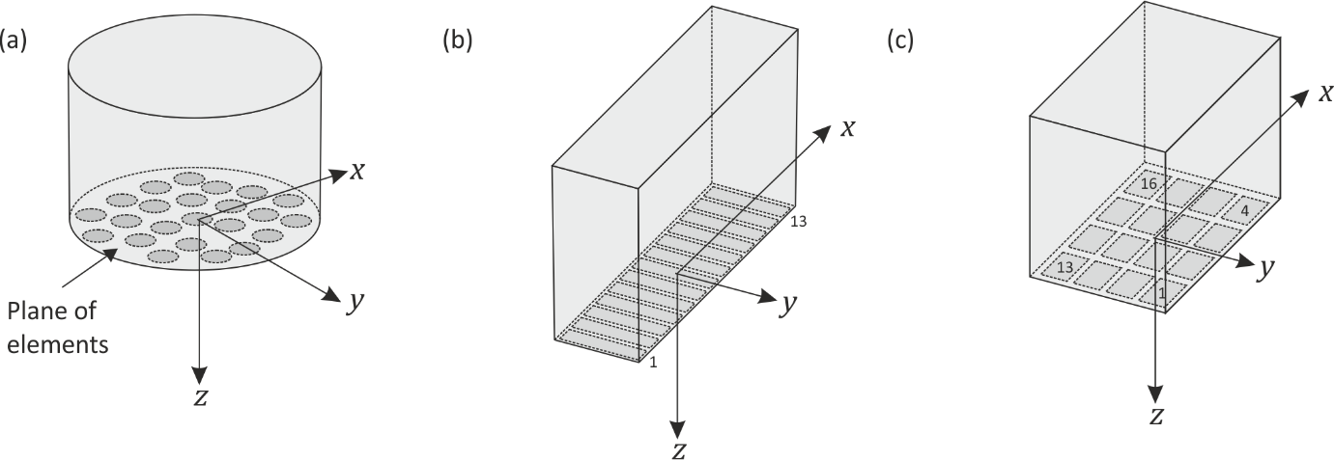

Fig. 3 Recommended conventions for Probe Coordinate System (PCS) for: (a) general case; (b) 1D linear probe; (c) 2D matrix array probe. The recommended element numbering scheme is indicated in (b) and (c).

#### Array Elements (/{probe}/ELEMENT_*)

Within /{probe}, the placement of each element in the PCS is given by the three [3,N_E<p>] datafields ELEMENT_POSITION and ELEMENT_{MAJOR/MINOR}. For all three element-placement datafields, the first dimension represents the components of a vector in the PCS and the second dimension represents the element index within the probe. The centre of each element is defined by the position vector, , in ELEMENT_POSITION as shown in Fig. 4. The orientation of each element is defined by the vectors in ELEMENT_MAJOR and ELEMENT_MINOR. For each element these are vectors, and , from the centre of the respective element to one of the tips of its major and minor axes respectively. The vectors and for each element should be orthogonal and in the plane of the element. If they are not orthogonal then should be given priority and the component of that is orthogonal to should be used for purposes such as determining the width of a rectangular element. The vectors and should be orientated such that their cross-product, , is in the direction of ultrasonic emission. The shape of an element is denoted by the integer value in the array ELEMENT_SHAPE. Currently only rectangular and elliptical elements are supported according to:

* 1 – rectangular, dimensions by , as shown in Fig. 4(a);
* 2 – elliptical, major axis length , minor axis length , as shown in Fig. 4(b).

Focused elements are specified through the optional ELEMENT_RADIUS_OF_CURVATURE and ELEMENT_AXIS_OF_CURVATURE datafields. These are interpreted as follows:

* Neither ELEMENT_RADIUS_OF_CURVATURE or ELEMENT_AXIS_OF_CURVATURE exists – elements are planar;
* ELEMENT_RADIUS_OF_CURVATURE exists but ELEMENT_AXIS_OF_CURVATURE does not – each element is a portion of a sphere with centre at a distance of ELEMENT_RADIUS_OF_CURVATURE in the direction relative to ELEMENT_POSITION, as shown in Fig. 4(c);
* ELEMENT_RADIUS_OF_CURVATURE and ELEMENT_AXIS_OF_CURVATURE both exist – each element is a portion of a cylinder with axis in the direction ELEMENT_AXIS_OF_CURVATURE passing through a point at a distance of ELEMENT_RADIUS_OF_CURVATURE in the direction relative to ELEMENT_POSITION, as shown in Fig. 4(d).

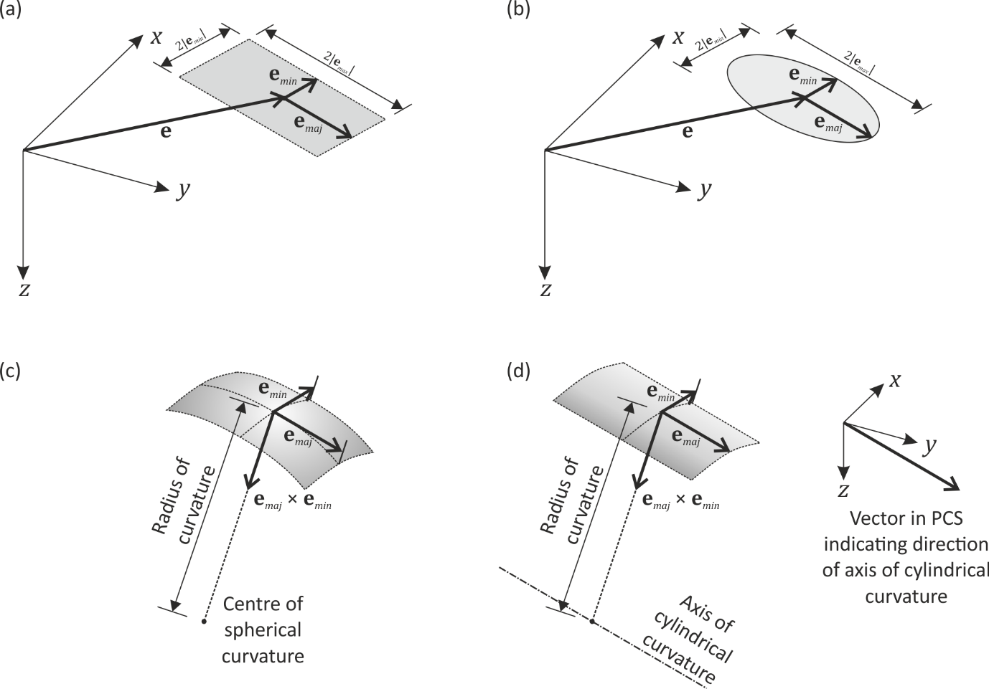

Fig. 4 Element geometry description in PCS: (a) rectangular element; (b) elliptical element; (c) spherically-focused element; (d) cylindrically-focused element.

#### Wedge (/{probe}/WEDGE_SURFACE_{POINT/NORMAL})

These optional parameters can be used to specify the geometry of a (rigid) coupling wedge with a planar working surface. The [3] attribute WEDGE_SURFACE_POINT specifies the position vector, , (in the PCS) of a point on the working surface of the wedge and the [3] attribute WEDGE_SURFACE_NORMAL specifies the working surface normal vector, , as shown in Fig. 5.

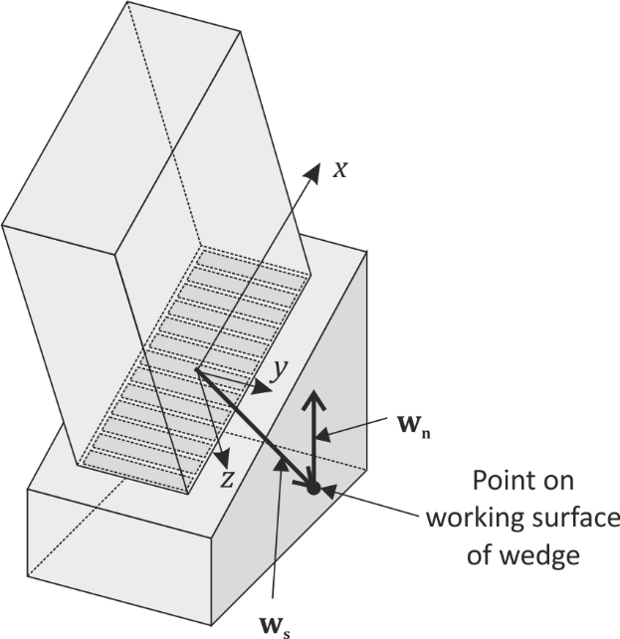

Fig. 5 Wedge geometry description in PCS.

#### Optional Probe Datafields

Within /{probe}/ the following optional fields are specified by the MFMC format:

* /{probe}/CENTRE_FREQUENCY – optional scalar attribute used to specify nominal centre-frequency of array;
* /{probe}/DEAD_ELEMENT – an optional [N_E<p>] datafield of logical values (0 = false, 1 = true) used to flag non-functioning elements in an array probe( if not present, assumption should be that all elements are performing correctly);
* /{probe}/BANDWIDTH – optional scalar attribute used to specify nominal ‑6 dB bandwidth of array;
* /{probe}/PROBE_MANUFACTURER – optional string attribute used to specify probe manufacturer;
* /{probe}/PROBE_SERIAL_NUMBER – optional string attribute used to specify probe manufacturer;
* /{probe}/PROBE_TAG – optional string attribute used to specify a tag for a probe;
* /{probe}/WEDGE_MANUFACTURER – optional string attribute used to specify wedge manufacturer;
* /{probe}/WEDGE_SERIAL_NUMBER – optional string attribute used to specify serial number for wedge;
* /{probe}/WEDGE_TAG – optional string attribute used to specify a tag for wedge.

### MFMC Sequence (/MFMC<m>)

An MFMC sequence contains one or more frames of data acquired under identical conditions except for probe position(s). The actual data is in the expandable [N_T<m>,N_A<m>,N_F<m>] dataset /{sequence}/MFMC_DATA (and for complex data the optional [N_T<m>,N_A<m>,N_F<m>] dataset /{sequence}/MFMC_DATA_IM may be used to record the imaginary component). The datafields /{sequence}/PROBE_POSITION and /{sequence}/PROBE_{X/Y}_DIRECTION describe probe placement; each A-scan in each frame is cross-referenced to one probe placement in these datafields.

#### Focal Laws (/{sequence}/{law})

Each A-scan in a frame must be associated with both a transmit and a receive focal law through the datafields /{sequence}/{TRANSMIT/RECEIVE}_LAW (note that these apply to all the frames in a sequence). These contain HDF5 references to the groups in /{sequence}/{law} which provide the detailed description of each focal laws (the same structure is used for both transmit and receive focal laws). In /{sequence}/{law}, the mandatory datafields are PROBE and ELEMENT. These indicate the PECs used for the focal law. For FMC/HMC data, only one PEC is used in transmission and one PEC in reception, so these datafields contain single values; however, for other acquisition modalities such as PWI, a focal law may specify multiple PECs. The optional datafields, DELAY and WEIGHTING in /{sequence}/{law}, specify the relative delay (in ultrasonic time) and weighting between the different PECs in the focal law. The default values, if these datafields are not present, are zero delay and unity weighting for all PECs.

#### Time-base (/{sequence}/TIME_STEP and /{sequence}/START_TIME)

All A-scans in all frames in a sequence must be uniformly sampled on a common ultrasonic time axis. Ultrasonic time zero on this axis should correspond to the instant when an ultrasonic pulse is emitted from the probe (for FMC/HMC data this is unambiguous, but for focal laws involving delays, the user needs to define exactly what time zero corresponds to). The time axis parameters are specified in /{sequence}/by the scalar attributes:

* START_TIME – the ultrasonic time of the first point in the A-scan (which need not be zero if, for example, the early portion of a signal is not of interest);
* TIME_STEP – the time step between adjacent points.

#### Ultrasonic Velocities (/{sequence}/{SPECIMEN/WEDGE}_VELOCITY)

Ultrasonic velocities in the specimen (and optionally wedge) are specified in /{sequence}/ by the [2] attributes {SPECIMEN/WEDGE}_VELOCITY. The first element is the shear velocity and the second is the longitudinal velocity.

#### Probe Placement (/{sequence}/PROBE_* and /{sequence}/PROBE_LIST)

Each A-scan in each frame in a sequence corresponds to the same duration of ultrasonic time. This duration is assumed to negligible compared to the timescale associated with mechanical movement of the probe(s), hence the probe(s) is assumed to be at a stationary placement for each A-scan. Commonly, it will be the case that multiple A-scans (e.g. all those in a single frame) are recorded at the same probe placement. For this reason and to avoid unnecessary duplication, only unique probe placements are recorded in /{sequence}/ with the expanding [3,N_Q<m>,N_B<m>] datafields PROBE_POSITION and PROBE_{X/Y}_DIRECTION. Each A-scan in each frame is cross-referenced into the probe-placement datafields through /{sequence}/PROBE_PLACEMENT_INDEX.

For all three probe-placement datafields the dimensions have the following interpretation. The first dimension, [3], refers to vector components in the GCS, and the third, expandable dimension, [N_B<m>], is the probe placement index. The second dimension, [N_Q<m>], is necessary because multiple probes with independent placements may be involved in a sequence (e.g. in a tandem configuration where one probe acts as a transmitter and one as a receiver). The size of this dimension is equal to the number of different probes used in the sequence and will often by unity. Indices in this dimension are cross referenced to the probe indices p in /{probe} through /{sequence}/PROBE.

The datafield, PROBE_POSITION, provides the position vector, , of the origin of each PCS in the GCS for each probe placement index, as shown in Fig. 6. The vectors, and , in PROBE_{X/Y}_DIRECTION specify the directions of the x- and y-axes of the PCS in the GCS, again as shown in Fig. 6. These should be orthogonal but if they are not, has priority and defines the x-axis direction of the PCS, while the component of that is orthogonal to defines the y-axis direction of the PCS. Note that the probe placement datafields work in a similar way to the ELEMENT_POSITION and ELEMENT_{MAJOR/MINOR} datafields in /{probe}/, except that (a) they use the GCS rather than a PCS and (b) the magnitude of PROBE_{X/Y}_DIRECTION vectors does not have any physical meaning in contrast to the ELEMENT_{MAJOR/MINOR} vectors.

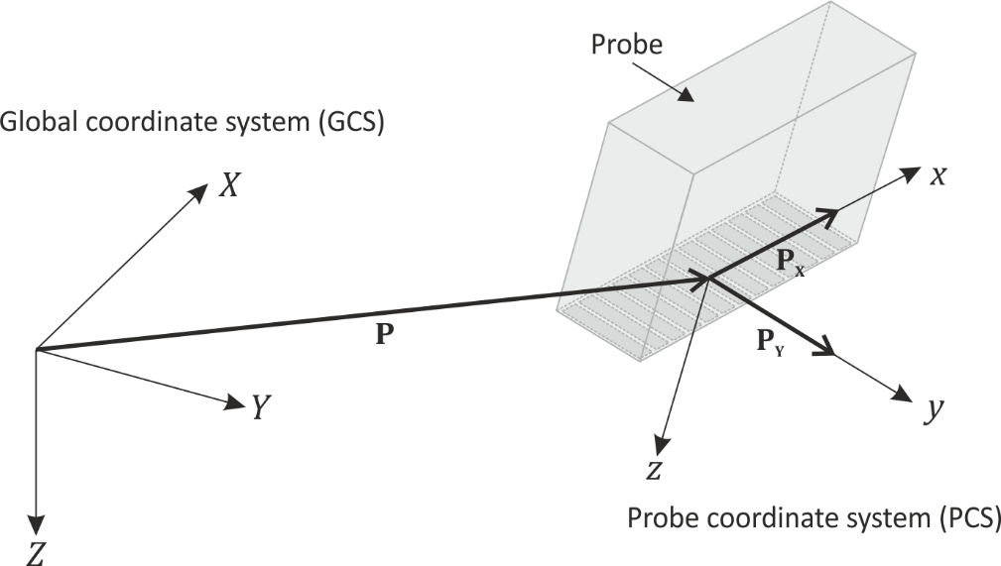

Fig. 6 Probe placement showing vectors , and defining position and orientation of PCS in GCS.

#### Optional MFMC Sequence Datafields

Within /{sequence}/ the following optional fields are specified by the MFMC format:

* TAG – optional string attribute used to specify a tag for sequence;
* DAC_CURVE – optional [N_T<m>] datafield for specifying distance amplitude correction curve (DAC), that has been applied to MFMC data (i.e. the data is post-DAC) which should be given on as linear (not decibel) values, one for each time sample in an A-scan;
* RECEIVER_AMPLIFIER_GAIN – optional scalar attribute for specifying receiver analogue gain as linear (not decibel) value;
* FILTER_TYPE – optional integer attribute for specifying type of analogue filter used (0 = no filter, 1 = low-pass, 2 = high-pass, 3 = band pass, 4 = other filter);
* FILTER_PARAMETERS – optional datafield providing analogue filter parameters (for FILTER_TYPE 1 or 2 this is a single value giving the ‑3 dB cut-off frequency; for FILTER_TYPE 3 this should contain two values for the lower and upper ‑3 dB cut-off frequencies; for FILTER_TYPE 4 this should be an [3,N_F<m>] matrix where the first row is frequency and the second and third rows provide the real and imaginary parts of the filter’s transfer function at that frequency);
* FILTER_DESCRIPTION – optional string attribute that can be used to provide a free text description of the analogue filter used;
* OPERATOR – optional string attribute to identify operator;
* DATE_AND_TIME – optional string attribute to specify date and time of acquisition of first frame in sequence, using the ISO 8601 extended format: 'yyyy-mm-dd HH:MM:SS' (e.g. '2019-01-16 17:05:06').